PF LAB 1
Task 3

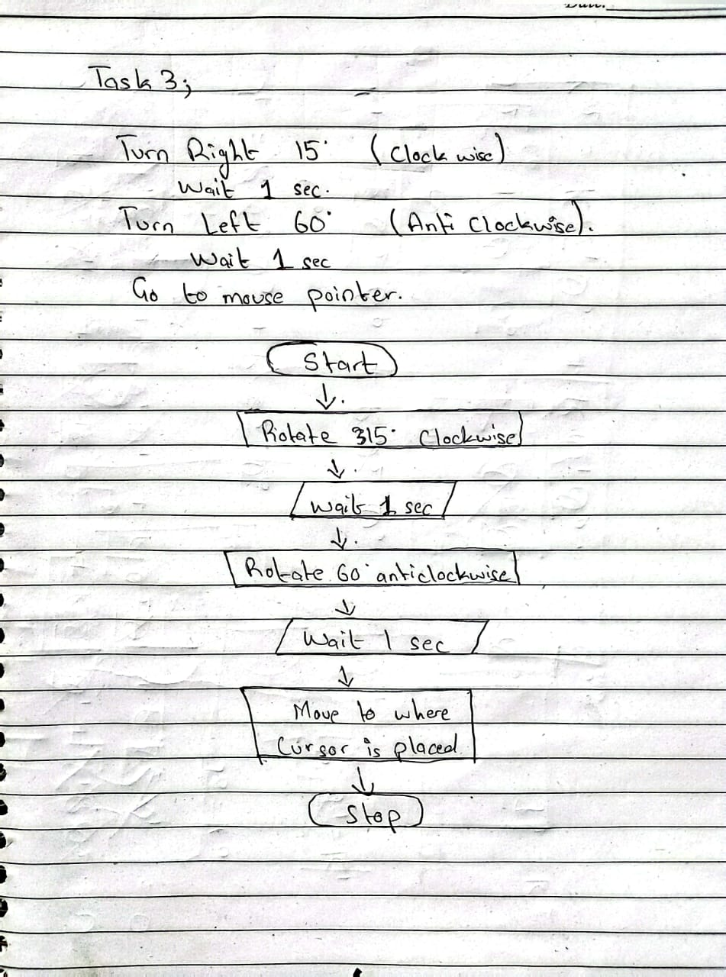

Task 4
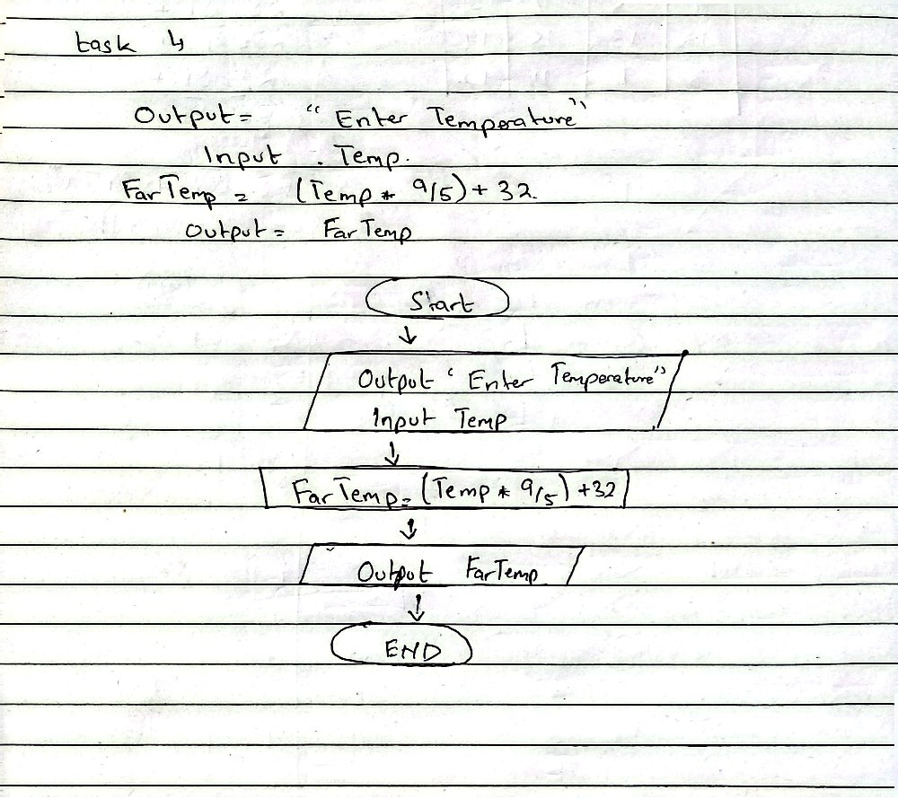

Task 5
- Output “Enter a number”
- Input num1
- Output “Enter second number”
- Input num2
- Sum= num1+num2
- Output Sum

Task 6
- Output “Enter your name”
- Input name
- Output “Hello”, Print (name)

Task 7
- Output “Enter marks for 3 subjects”
- Input num1
- Input num2
- Input num3
- Sum=num1+num2+num3
- Percentage=(sum/300)*100
- Output sum, “are the total marks”
- Output percentage , %
Task 8
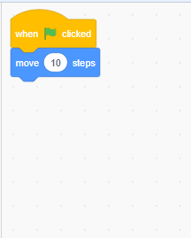

Task9
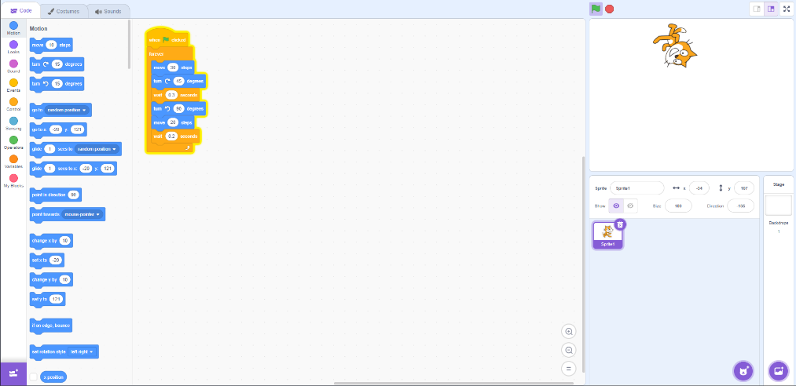

Task 10

